Question 1

SELECT CONCAT(UPPER(fname),' ',UPPER(lname)) as fullname from worker_table;

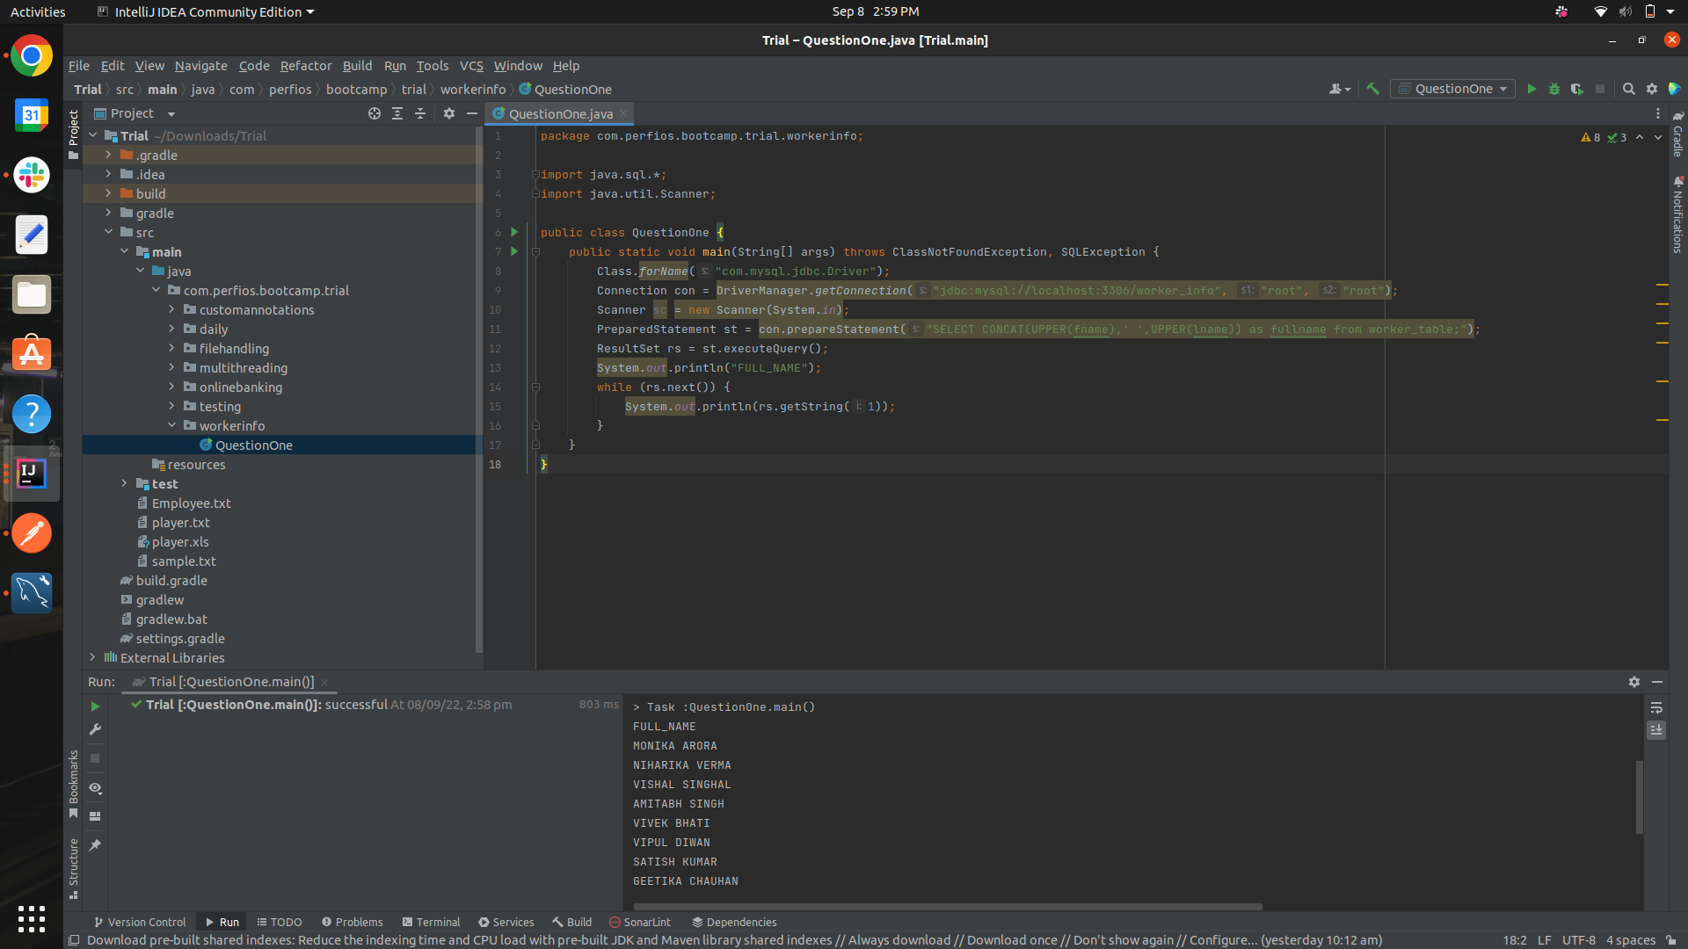

Question 2

SELECT DISTINCT(department) FROM worker_table;

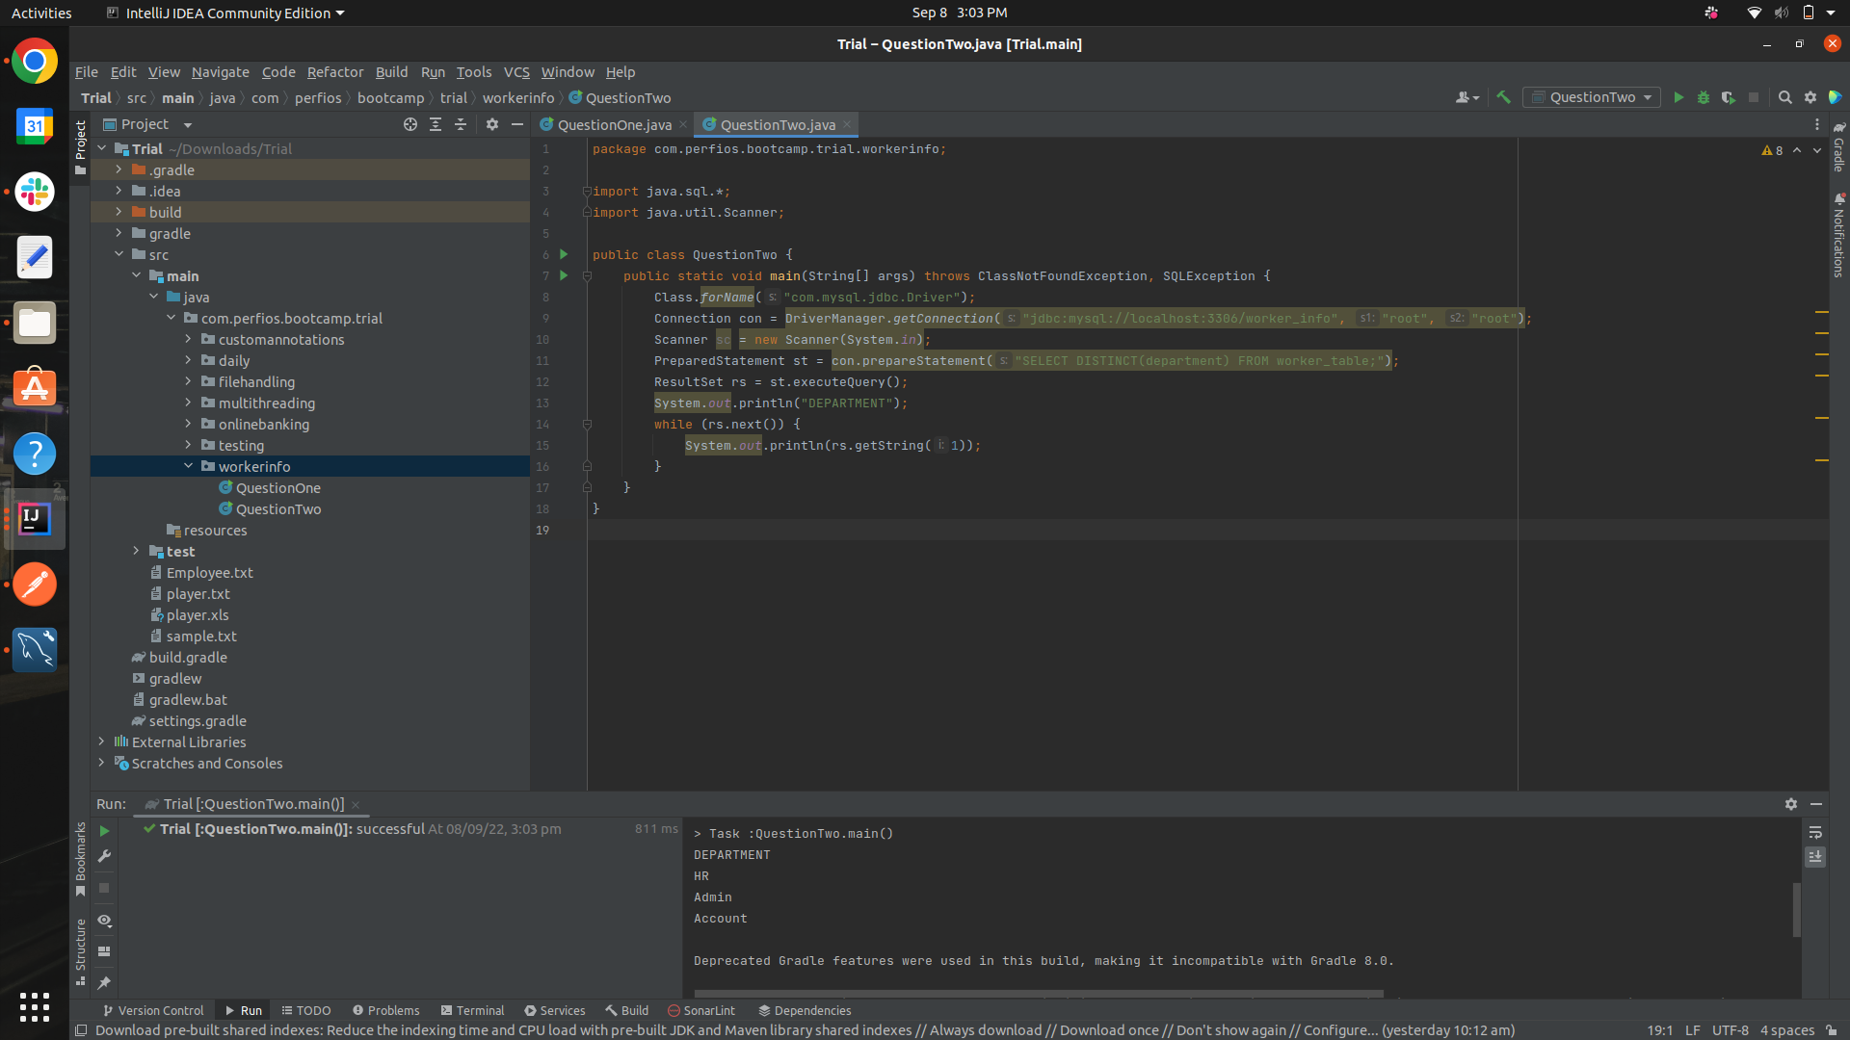

Question 3

SELECT fname, POSITION("a" IN fname) FROM worker_table where worker_id =4;

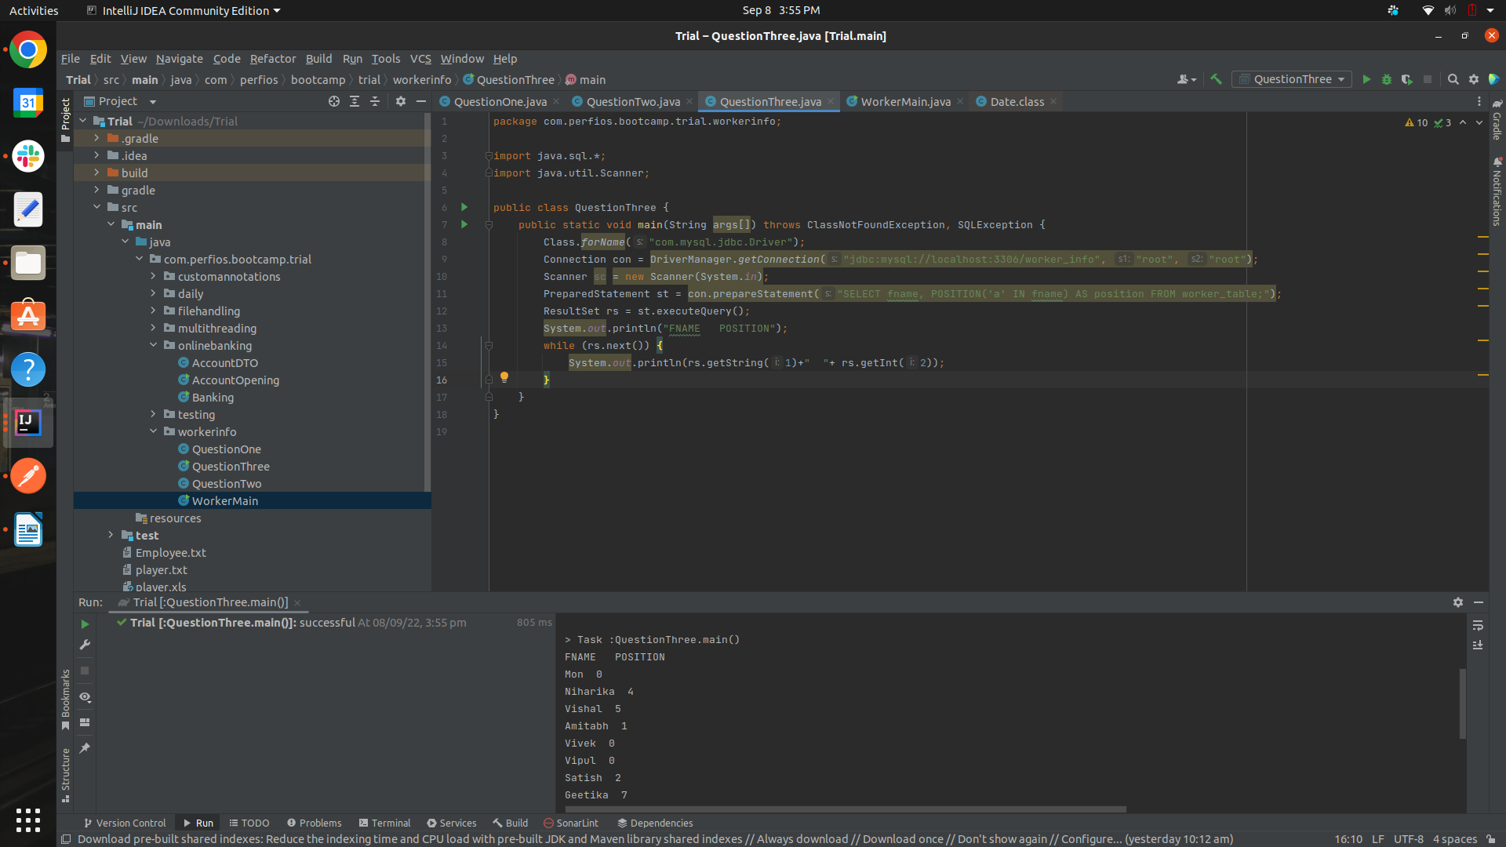

CRUD

